1. **ReactJS-HOL**

**CalculateScore.js**

import React from 'react';

import '../Stylesheets/mystyle.css';

const percentToDecimal = (decimal) => {

return (decimal * 100).toFixed(2) + '%';

};

const calcScore = (total, goal) => {

return percentToDecimal(total / goal);

};

export const CalculateScore = ({ Name, School, total, goal }) => {

return (

<div className="formstyle">

<h1><font color="brown">Student Details:</font></h1>

<div className="Name">

<b><span>Name: </span></b>

<span>{Name}</span>

</div>

<div className="School">

<b><span>School: </span></b>

<span>{School}</span>

</div>

<div className="Total">

<b><span>Total: </span></b>

<span>{total}</span> Marks

</div>

<div className="Score">

<b>Score:</b>

<span> {calcScore(total, goal)}</span>

</div>

</div>

);

};

export default CalculateScore;

**mystyle.css**

.Name {

font-weight: 300;

color: blue;

}

.School {

color: crimson;

}

.Total {

color: darkmagenta;

}

.Score {

color: forestgreen;

}

.formstyle {

text-align: center;

font-size: large;

}

**App.js**

import React from 'react';

import CalculateScore from './Components/CalculateScore';

function App() {

return (

<div>

<CalculateScore Name="Nallamani J" School="CEOA Matriculation School" total={492} goal={500} />

</div>

);

}

export default App;

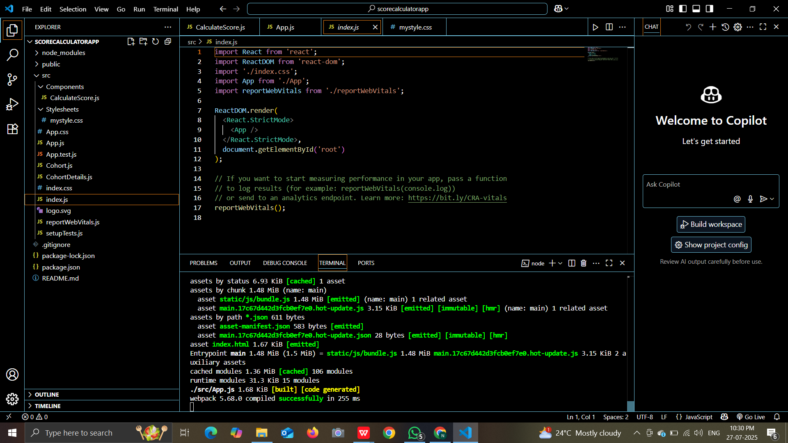

**OUTPUT:**

